| **Project Title** | | | Recipe Recommendation Based On Ingredients  Recognition Using CV AND ML | | | |
| --- | --- | --- | --- | --- | --- | --- |
| **Batch No** | | | 14 | | | |
| **Week Starting Date** | | | 28-03-2022 | **Week Ending Date** | | 03-04-2022 |
| **Name** | | | A R Manyatha  Amulya S Dinesh  Manasi Swain  Mihir Soni | **SRN** | | PES2UG19CS002  PES2UG19CS035  PES2UG19CS216  PES2UG19CS232 |
| **Activities Completed** | | | | | | |
| **#** | | **Tasks** | | **Date** | **Remarks** | |
| 1 | | Architecture of project | | 30-03-2022 |  | |
| 2 | | Research on architecture | | 28-03-2022 |  | |
| 3 | |  | |  |  | |
| **In Progress** | | | | | | |
| **#** | **Tasks** | | | **Date** | **Remarks** | |
| 1 | Documentation | | | 29-03-2022 |  | |
| 3 |  | | |  |  | |
| **Plan for Next Week** | | | | | | |
| **#** | | **Tasks** | | **Date** | **Remarks** | |
| 1 | | Look into CV models | | 04-04-2022 |  | |
| 2 | |  | |  |  | |

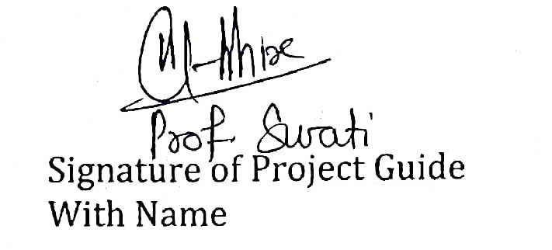

| Signature of Project Guide  With Name | Signature of Project Coordinator | Signature of Chairperson |
| --- | --- | --- |